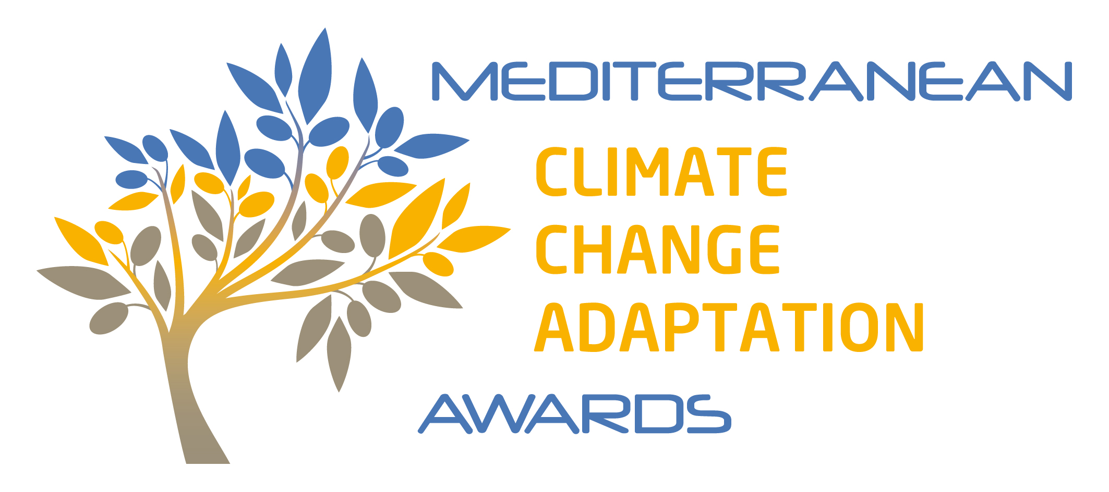

Special edition
“Building and Construction sector”

APPLICATION FORM

Reminder of how to enter the competition
- Download the application form from Awards’s website

- https://www.medadapt-awards.com/en/enter-the-competition/

- Fill in the application file, which consists of the summary-sheet and the form

NB: Files must be completed in English or French.

- Upload the completed application file, (EXTENSION OF TIME LIMIT) before 10 p.m. on Tuesday April 18, 2023, (UTC-00:00) to:

- https://www.medadapt-awards.com/en/enter-the-competition/

- Click on “send” to validate the submission of your application (a confirmation email will be automatically sent to you)

- Short-listed candidates will be invited to attend the awards ceremony, which will take place in May 2023, during meetMED weeks (Marrakech - Morocco).

Note: unsuccessful applications will be notified by email.

Reminder of the application file assessment criteria
Application files will be assessed according to the following criteria:
- outcomes of the action in terms of adaptation to climate change
- exemplarity in implementing the adaptation action
- potential for replicating the adaptation action in other areas
- illustration of the 10 principles for Effective action proposed by GlobalABC - https://globalabc.org/resources/publications/adaptation-building-sector-climate-change-10-principles-effective-action

Reminder of key competition dates

Additional information
- The call for applications, the application form and the competition rules can be downloaded free of charge from Awards’s website:

- https://www.medadapt-awards.com/en/enter-the-competition/

- Further information regarding the “Mediterranean Climate Change Adaptation Awards” may be obtained by email by contacting:

- email – contact@medadapt-awards.com
- contact form on website - www.medadapt-awards.com/en/contact-us/
SUMMARY SHEET TO BE COMPLETED
Important: Please do not exceed the space provided for this summary sheet (1 page)
YOUR ORGANISATION (AND YOUR PARTNERS)
Action leader(s)
Key partners
(if any)
Your country
Area(s) concerned
(name of area, surface area, number of inhabitants, etc.)
YOUR ACTION
Title of the action
KEY POINTS OF YOUR ACTION
Geographical context of the action
Consequences of climate change justifying the adaptation action
Objective(s) of the adaptation action
Implementation schedule
Description of the action
Outcome achieved
Potential for replication
illustration of the 10 principles  (Check principles) | 1. Urgency/ Act now.  2. Stakeholders/ Consider a systemic integration of measures for adaptation across the entire value chain.  3. Process/ Consider adaptation along the entire lifecycle of an asset.  4. Mitigation/ Implement adaptation and mitigation in tandem.  5. Data/ Understand climate risk data and accept uncertainty.  6. Scale/ Think beyond asset-level.  7. Green/ Consider nature-based solutions.  8. People/ Promote a “just adaptation” of the building sector.  9. Finance/ Enable adaptation of the building sector.  10. Local/ Fit adaptation measures to the local context

FORM TO BE COMPLETED

Important: Please provide a succinct, concrete answer for each of the questions below, not exceeding the stipulated number of lines. You are invited to include photos or diagrams to illustrate your adaptation action (no more than four).

CONTACT PERSON
First name, surname
Position
Organisation
Telephone
Email
Postal address
Country

NB: Notes explaining the requirements for each question are provided at the end of the questionnaire.

Adaptation to climate change: “The process of adjustment to actual or expected climate and its effects. In human systems, adaptation seeks to moderate or avoid harm or exploit beneficial opportunities. In some natural systems, human intervention may facilitate adjustment to expected climate and its effects”. (IPCC)

- What is the geographical context of your action? (maximum 15 lines)

- Which challenge of adapting to climate change does your action address and how did you diagnose future climate impacts? (maximum 15 lines)

- In what context was your action decided upon? (maximum 15 lines)

- What objective(s) does this action intend to achieve? (maximum 20 lines)

- Does this action benefit from political / institutional backing? (maximum 10 lines)

- What resources (human, financial, technical, etc.) were deployed to set up this action? (maximum 20 lines)

- What partners/players did you mobilise to design/implement your action? How did you go about this? (maximum 10 lines)

- What methods, knowledge and bibliographical resources did you mobilise to define your action? (maximum 10 lines)

- What is the schedule for implementing your action? (maximum 10 lines)

STEP | DESCRIPTION | SCHEDULE (month/year)
Step 1
Step 2
Step 3
…

- How are you monitoring and evaluating this adaptation action? (maximum 10 lines)

- What are the outcomes in terms of adaptation to climate change? What are the tangible benefits of your action? (maximum 15 lines)

- Is your adaptation action bringing about co-benefits (environmental, social, economic, etc.)? (maximum 15 lines)

- To what extent does your climate change adaptation action illustrate the 10 following principles? Quote and specify your approach. (maximum 30 lines)

1. Urgency/ Act now.
2. Stakeholders/ Consider a systemic integration of measures for adaptation across the entire value chain.
3. Process/ Consider adaptation along the entire lifecycle of an asset.
4. Mitigation/ Implement adaptation and mitigation in tandem.
5. Data/ Understand climate risk data and accept uncertainty.
6. Scale/ Think beyond asset-level.
7. Green/ Consider nature-based solutions.
8. People/ Promote a “just adaptation” of the building sector.
9. Finance/ Enable adaptation of the building sector.
10. Local/ Fit adaptation measures to the local context

- What were the keys to the success of this action? (maximum 15 lines)

- To what extent and in what conditions do you consider it possible to replicate this action in other areas? (maximum 15 lines)

- List here up to five visuals to illustrate your action (map ; picture ;photo, video link,…)
- ______
- ______
- ______
- ______

NOTES - EXPLANATIONS ON THE APPLICATION FORM

1 | What is the geographical context of your action? (maximum 15 lines) | Specifiy the geographical features (steep-sided valley, river bed, etc.) and socio-economic factors characterising the local context for your climate change adaptation action.
2 | Which challenge of adapting to climate change does your action address and how did you diagnose future climate impacts? (maximum 15 lines) | State the observed and/or expected change to the climate (annual precipitation / average temperatures etc.) and the observed and/or expected consequences (e.g. depleted water resources, increased urban heat, coastal flooding, desertification, etc.) justifying your adaptation action.
3 | In what context was your action decided upon? (maximum 15 lines) | An adaptation action may originate in several types of context:  - A need to face the consequences of a climate change already being observed (e.g. adaptation of agriculture or forestry practices, coastal development, etc.)  - A voluntary initiative to anticipate the future consequences of climate change (e.g. adaptation or even transformation of tourist facilities, modification of urban development practices, relocation of socio-economic activities, etc.).  - Political will, citizens’ initiative or context of cooperation (e.g. strong local political will to anticipate the consequences of climate change for sectors of the economy and the population; partnerships or collaborative projects encouraging adaptation; a citizens’ movement to face consequences of a climate change already being observed, etc. It is important to demonstrate that the scope of the action goes beyond what is permitted by current legislation in the area concerned.
4 | What objective(s) does this action intend to achieve? (maximum 20 lines) | The actions must have been implemented or be in progress (projects that have not been launched will not be admissible) and present measurable outcomes in terms of adaptation to climate change.  Actions should cover buildings, equipment, infrastructure and facilities related to the construction sector. They can fall under different approaches and typologies defined by the international community:.  - "Grey" solutions: For example, we can mention urban planning actions aiming to improve summer thermal comfort or rainwater management, integrated coastal zone management actions, building adaptation actions (insulation, shading solutions, natural ventilation, bioclimatic design, etc), actions aiming to reinforce the robustness of networks and infrastructures to climatic events...  - “Green" solutions - Examples include: urban cooling actions based on ecosystems (soil, water, vegetation), development actions to promote ecological continuity, actions to control the demand for drinking water or to mobilise alternative resources, greening of roofs and facades, etc.  - Soft solutions: For example, we can mention: research programmes, territorial observation programmes, nudge practices/changes in working hours, "cold" audits, actions aimed at training/raising awareness/commitment of actors and decision-makers in the territories, incentive and/or regulatory actions, actions aimed at integrating climate change into public policies...
5 | Does this action benefit from political institutional backing? (maximum 10 lines) | State here whether the action benefits from any form of political or institutional backing and, if so, at what levels (local, regional, national, international).
6 | What resources (human, financial, technical, etc.) were deployed to set up this action? (maximum 20 lines) | In this section, please state:  - the human resources that either exist (and the time allocated to the assignment) and/or are new (positions created to implement and monitor this action);  - the technical resources (for example: performance of preliminary studies, organisation of a mediation process, engineering work, use of a communication agency, etc.);  - the estimated total cost of this operation and its funding methods (own funds, support from a funding body, research and/or cooperation programme, etc.).
7 | What partners/players did you mobilise to design/implement your action? How did you go about this? (maximum 10 lines) | In this section, state whether the action mobilised:  - only the project sponsor;  - the services of the local authority (if so, which ones and under what conditions?)  - other partners/stakeholders (in this case, which ones and under what conditions: consultation, public meetings, mediation, etc.).
8 | What methods, knowledge and bibliographical resources did you mobilise to define your action? (maximum 10 lines) | In this section, state the methods used to identify the adaptation issues, plan the action, and monitor and evaluate it. For example, the action sponsor may mobilise: existing reports and data made available by government departments, regional authorities, international organisations (e.g. Plan Bleu) and the research community; methods or guidelines proposed by agencies (e.g. ADEME) or funding bodies; collective memory and knowledge; consultation of experts; assistance from a specialist service-provider.
9 | What is the schedule for implementing your action? (maximum 10 lines) | In this section, state the different stages involved in implementing your action and indicate the schedule associated with each stage.
10 | How are you monitoring and evaluating this adaptation action? (maximum 10 lines) | In this section, state whether this action has been monitored and evaluated and, if it has, the implementation and performance indicators identified
11 | What are the outcomes in terms of adaptation to climate change? What are the tangible benefits of your action? (maximum 15 lines) | In this section, state in concrete terms how the action implemented has fostered adaptation to climate change
12 | What are the outcomes in terms of adaptation to climate change? What are the tangible benefits of your action? Is your adaptation action bringing about co-benefits (environmental, social, economic, etc.)? (maximum 25 lines) | If this action brought about spin-offs other than those related to climate change adaptation, state them here. Co-benefits include: improved quality of life; greater social cohesion; reduced poverty; reduced greenhouse gas emissions; protected ecosystems; establishment of a new cooperation-based relationship.
13 | To what extent does your climate change adaptation action illustrate the 10 following principles ? Quote and specify your approach. (maximum 30 lines) | The 10 principles are elaborated further https://globalabc.org/resources/publications/adaptation-building-sector-climate-change-10-principles-effective-action  You can show here how your approach, your action can illustrate one or more of these principles :  1. Urgency/ Act now.  2. Stakeholders/ Consider a systemic integration of measures for adaptation across the entire value chain.  3. Process/ Consider adaptation along the entire lifecycle of an asset.  4. Mitigation/ Implement adaptation and mitigation in tandem.  5. Data/ Understand climate risk data and accept uncertainty.  6. Scale/ Think beyond asset-level.  7. Green/ Consider nature-based solutions.  8. People/ Promote a “just adaptation” of the building sector.  9. Finance/ Enable adaptation of the building sector.  10. Local/ Fit adaptation measures to the local context
14 | What were the keys to the success of this action? (maximum 15 lines) | State here how your action could be geared to as many climate change scenarios as possible, as well as the anticipated changes to natural and socio-economic systems.  State what, from your leader’s standpoint, played a decisive role in making this action successful. If this action met any setbacks during the design or implementation period, describe them and the means by which you overcame them. Examples: political backing; technical issues (technology, knowledge, etc.); social issues (relating to social acceptance of the action, public consultation, etc.); financial issues; legal issues, etc.
15 | To what extent and in what conditions do you consider it possible to replicate this action in other areas? (maximum 15 lines) | In this section explain how the action could be replicated, to help other regions and players face similar consequences of climate change. Within what time frame, and using what resources?
16 | List here up to five visuals to illustrate your action (map ; picture ;photo, video link,…) | For example, it can be photos, maps, plans or communication tools such as a flyer or a video presentation of the process http: XXX  Each visual must not exceed 1MB; it must be sent in PDF or JPEG format;

